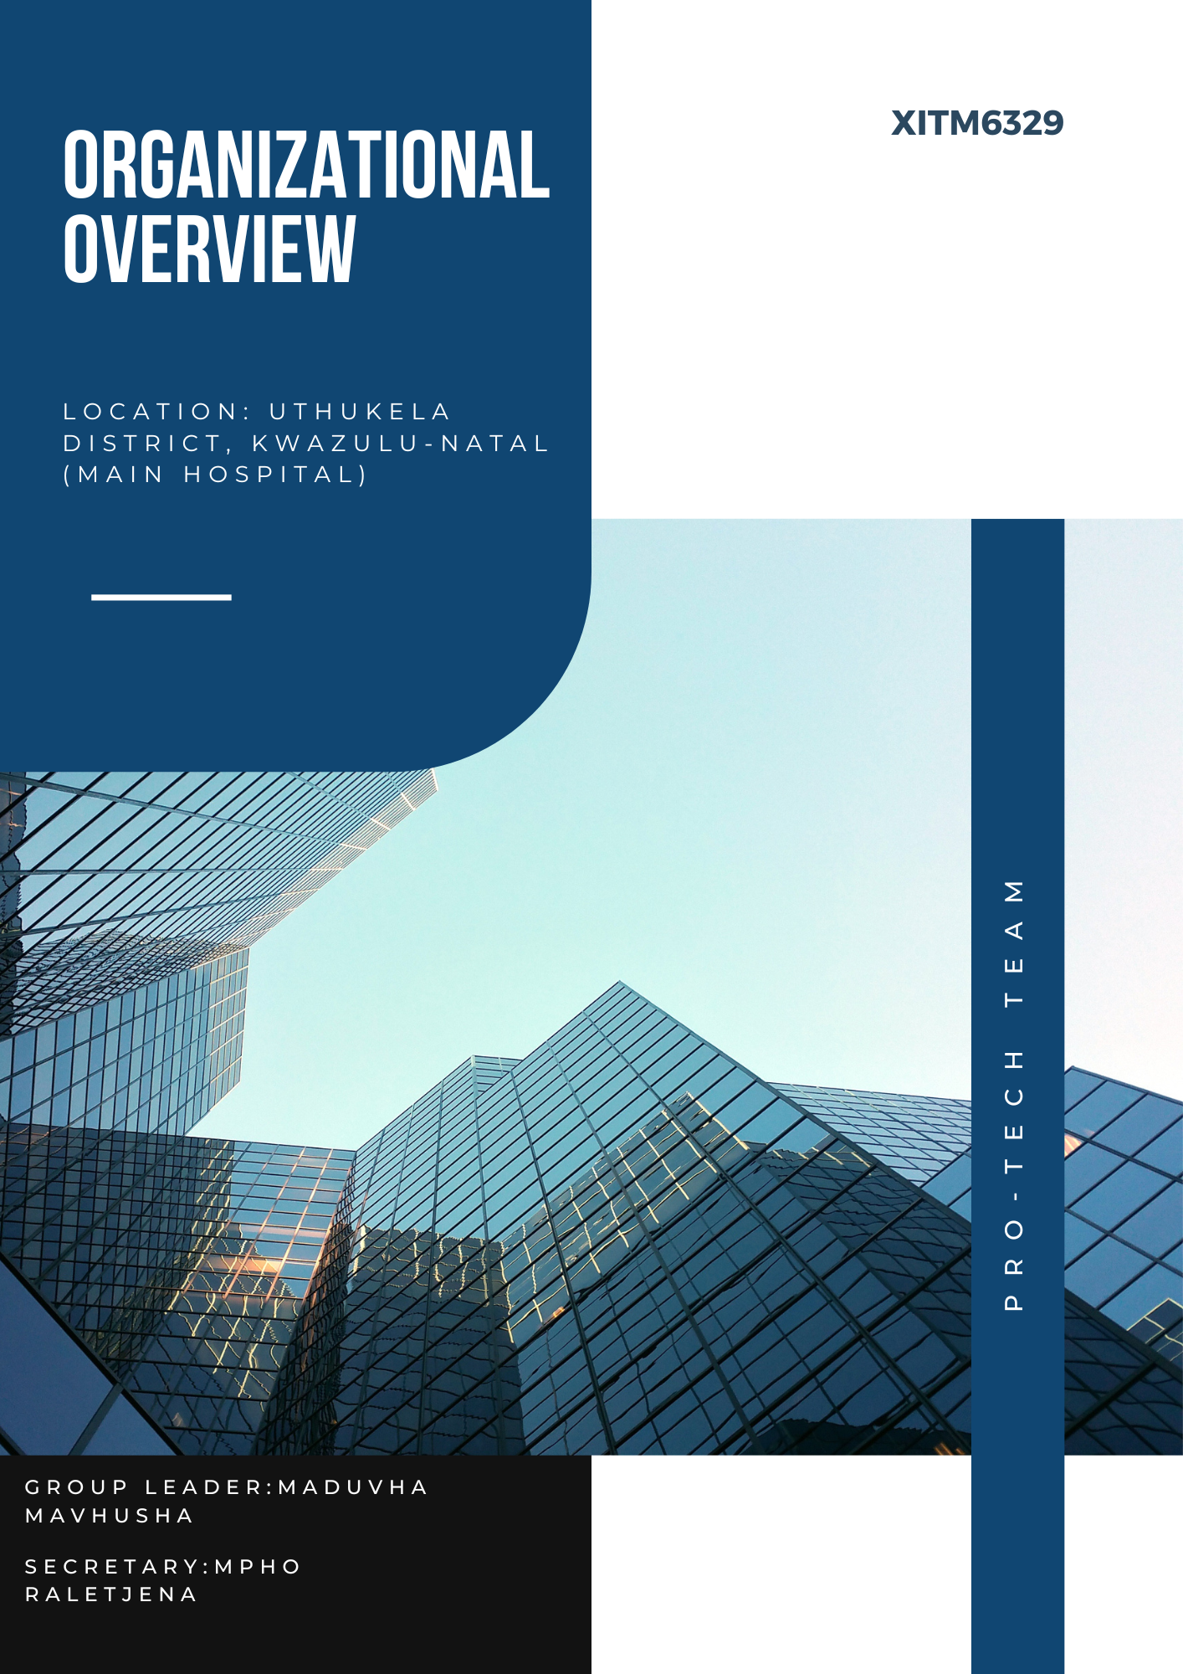

**Table of Contents**

Mission 2

Key Project 2

Objective 2

Stakeholders 2

ICT Support Staff 2

Current Infrastructure Assessment 2

Project Requirements 2

Training and Support 2

Timeline 3

ProTech Team's Commitment 3

## **Mission**

* ProTech Team is dedicated to bridging the digital divide by developing and implementing sustainable network infrastructures in remote and underserved regions. Our mission is to provide reliable and secure connectivity that supports essential services and promotes community development.

## **Key Project**

Project Title: Crossing the Digital Divide with a Simple Bridge in the uThukela District

## **Objective**

* Develop and implement a world-class network infrastructure to provide Internet connectivity to the main hospital in the uThukela district, ensuring the project's sustainability and self-sufficiency post-completion.

## **Stakeholders**

* uThukela District Municipality, local authority overseeing the project.
* Main Hospital in uThukela, beneficiary of the new network infrastructure, employing 2000 staff and serving 100 patients daily.
* Open serve, recommended carrier for connecting the newly developed infrastructure.

## **ICT Support Staff**

* A team of 5 responsible for maintaining the hospital's network infrastructure.

## **Current Infrastructure Assessment**

* The hospital is located 1 km from the existing network, visible by direct line of sight.
* Facilities include 45 patient wards and 5 offices.
* Existing equipment comprises 20 outdated computers and 5 printers.
* Lack of necessary security measures for network protection.
* Significant concerns regarding data storage and missing patient files.
* Various operational, financial, and supply chain software packages in use.
* The hospital's ongoing interaction with suppliers requires stable Intralink services.

## **Project Requirements**

* Implement a sustainable IT infrastructure model by extending an existing network to the hospital.
* Ensure fast, reliable, and dedicated Internet connectivity.
* Install necessary security measures to protect the network from threats.
* Support hospital operations, financial management, and supply chain activities.
* Enable connectivity for suppliers accessing Intra-link services.

## **Training and Support**

* Provide comprehensive training for the 5 ICT support staff on new infrastructure installation, troubleshooting, and equipment replacement.

## **Timeline**

* Complete and roll out the project within one year.

## **ProTech Team's Commitment**

* ProTech Team is committed to delivering a high-quality network infrastructure that meets the needs of the uThukela district's main hospital. Our approach emphasizes sustainability, security, and reliability, ensuring long-term benefits for the community we serve.